### Power BI Assignment

### Day-1

### What are the various versions of Power BI?

### Answer: -

### There are three based on license type: Free (Power BI Desktop), Pro (Power BI Report Server and Mobile) and PPU (Premium Per User)

### Day-2

### Drag the Country from the region_data then in the report view and mention the name of the visual in the text box and add the labels in the visual.

### 

### Day-3

1. Create a basic map visual on the report page using the Global superstore and Use the region column in the slicer visual to get interacted with the map visual.

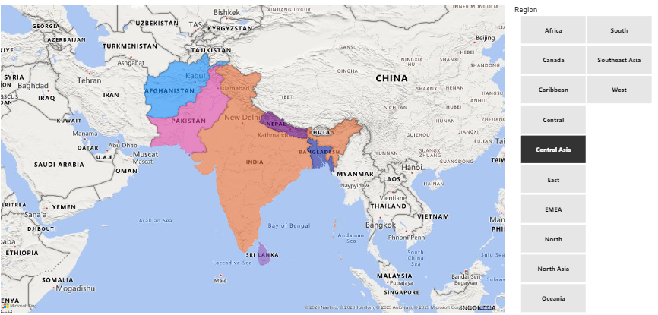

### Day-4

### Create a basic scatter plot using sales and Profit information and represent it (refer to region column), which helps identify the highest green color and lowest sales red color.

### Day-5

### Create a line and clustered chart and compare this year vs last year's sales along with growth % ?

ANS)

Used data set: **Global Superstore**

**Line chart:**

**Sales by Year for all the years**

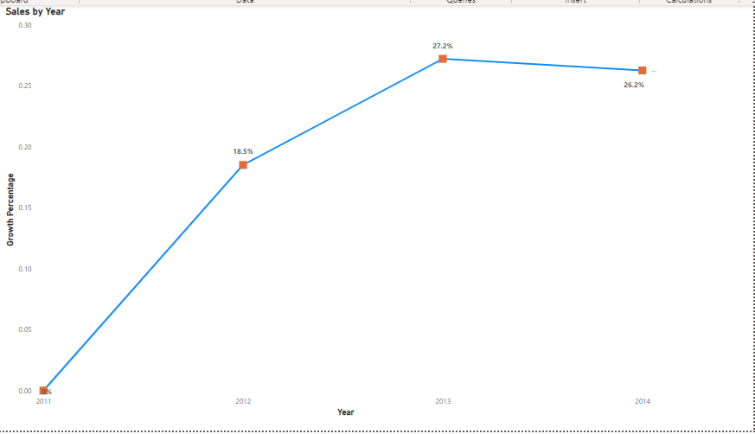

**Sales by Year (Current vs Previous year)**

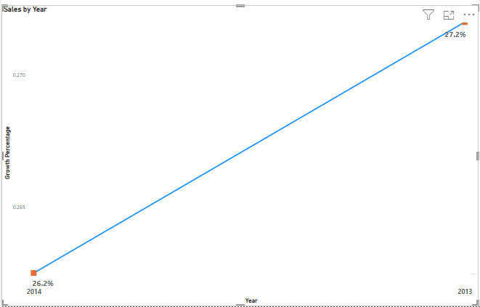

**clustered chart:**

**Sales by Growth % by Current year vs Previous year**

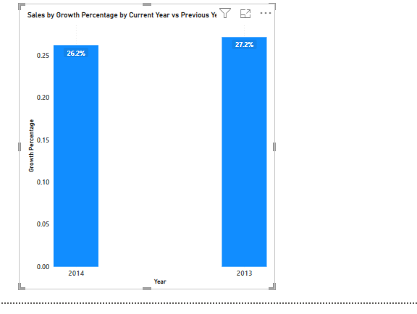

**Sales by Growth % all four years:**

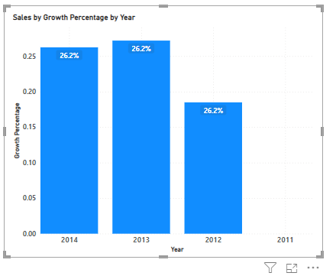

**Sales by year**

**Clustered chart and line chart**

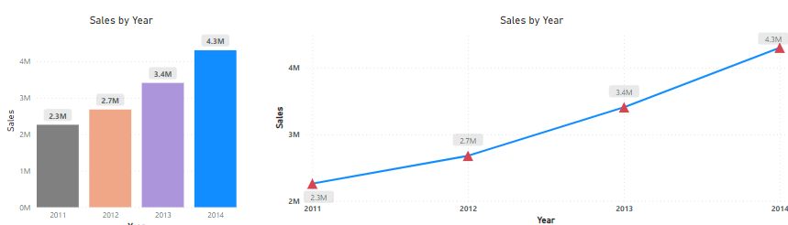

### Day-6

### Import data from [2023 Worldwide Box Office - Box Office Mojo](https://www.boxofficemojo.com/year/world/?ref_=bo_nb_yl_tab) and add the past 3 years of data in the Power Query editor, create a master table of the past 3 years of data, and load only master data in the power bi query editor or power bi desktop?

### Ans)

### Data import perfomed using url: <https://www.boxofficemojo.com/year/world/>

### Loaded past 3 year tables (2020, 2021, 2022)

### Appended all three years as Master Data

### Performed transformation – Removed nulls, changed data type, fixed errors by changing the data type from locale, added year column

### 

### 

### 

### Delete unwanted columns, replace, or remove the error value in the master table and format the data and represent the column quality.

### Ans)

### Transformation applied on Master Date containing past three-year data:

### Renamed columns

### Replaced Errors, blanks

### Changed data type appropriately

### Added years

### Below column quality tool showing I have fixed issues per question number 7:

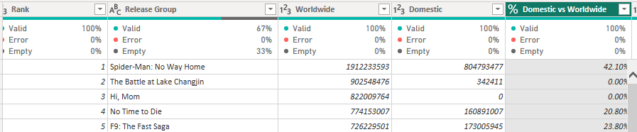

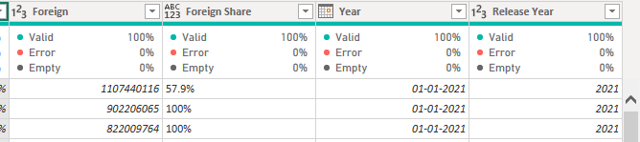

### Day-7

### Add all 3 tables from the model and create a table to show the detailed information for each day wise the sum of order quantity, shipped quantity, and delivered quantity. Kindly use a card visual to show the difference between the total order quantity and the shipped quantity, the 2nd difference between total order quantity and delivered quantity, using quick measure.

### Ans) Measure:

### 

### 

### Card Visual:

### 

### Tables showing total orders, shipping, and delivered quantities day wise:

### 

1. If there is a difficulty with tables having many-to-many relationships. Create an intermediate table (also known as a bridge table) to handle many-to-many relationship issues.

**Ans)** There was no difficulty in creating relationship; I have used Left outer join (default) while merging three tables to get answers for 8th question (above).

### Day-8

1. Refer to question no. 6! After importing all the 3 years of the data, kindly add the custom column of specific year data for e.g. (if you have imported the data for the year 2023, please create a new column called year and add 2023 for each row).

Ans) I have loaded past 3 years data per question #6: 2022, 2021, & 2020

Added Column “Year” > Column from examples> entered corresponding year to the entire column; extracted Year as “Release Year” column.

Image showing year or Release Year column with corresponding movie released date under Master data:

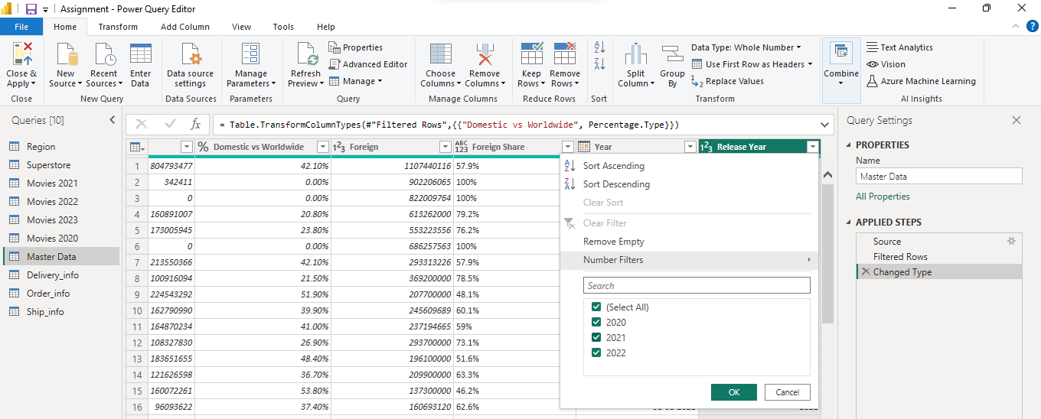

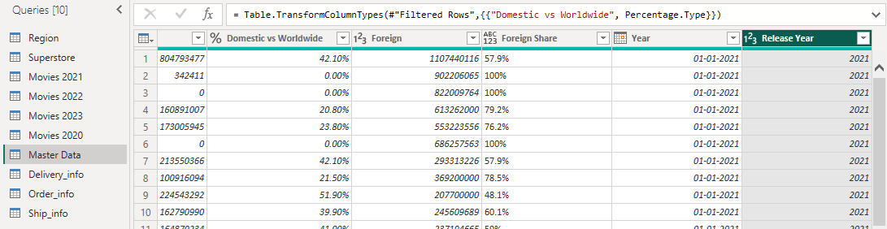

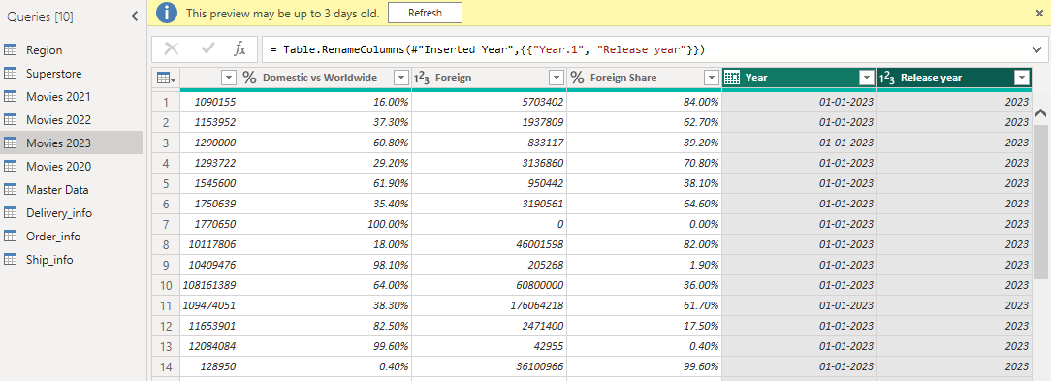

### Day-9

### Refer to Global superstore data.

1. Create a map visual and use the drill down to show detailed information for each country by state. (For detailed information you can use the region slicer).

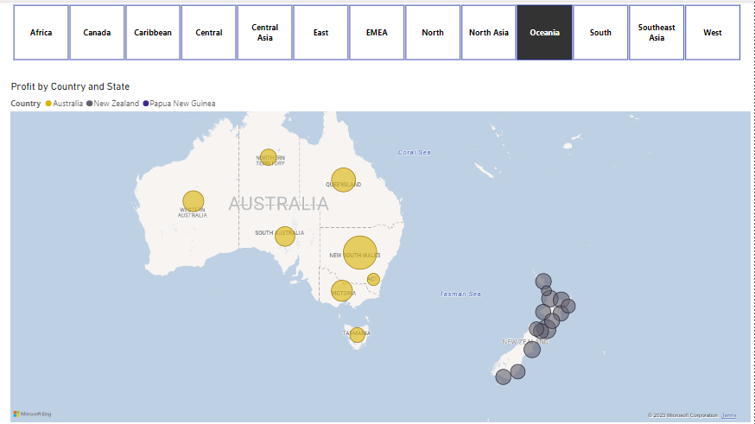

### Day-10

Refer to Financials sample data.

1. Create a clustered column chart referring to the order date and sales, then apply bookmarks based on date year, quarter, and month.  
   Chart, bar chart

   Description automatically generated

Ans) Created three charts with bookmarks that navigates to the chart based on bookmark selection:

1. **Sales, COGS and Profits by Quarter chart**

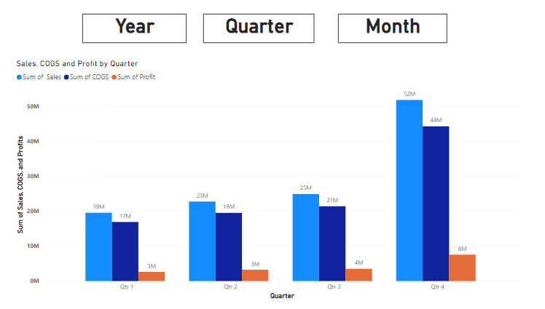

1. **Sales, COGS and Profits by Year**

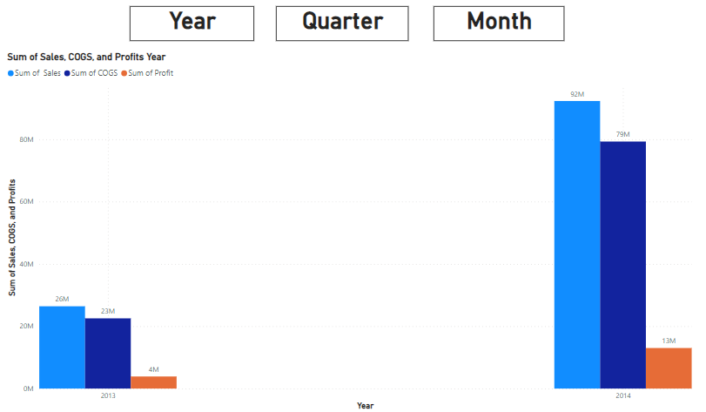

1. **Sales, COGS and Profits by Month**

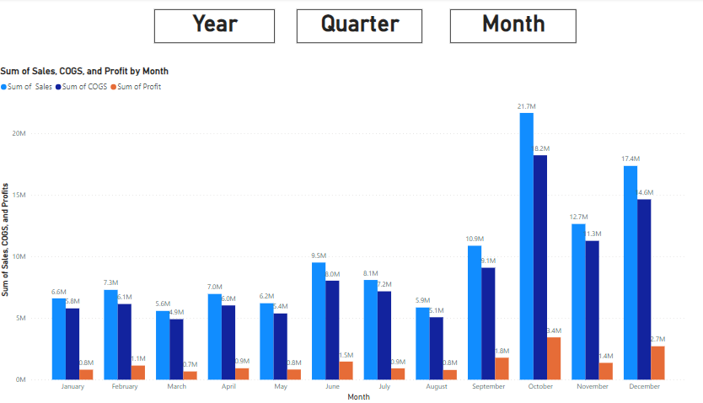

1. Create a country overview page and add another page that contains detailed information about the country with drill through options.

**Country wise overview:**

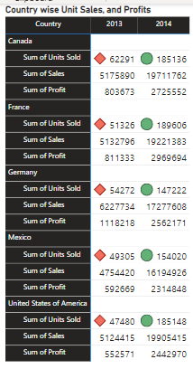

**Country wise overview with drill down option:**

Added date to Hierarchy

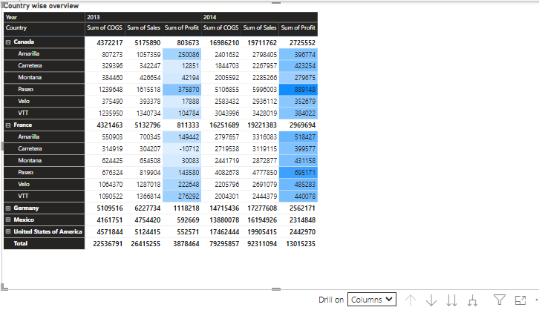

**Drill through year and quarter:**

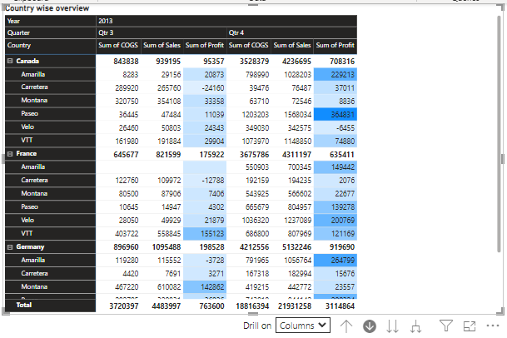

**Drill down through Quarter view:**

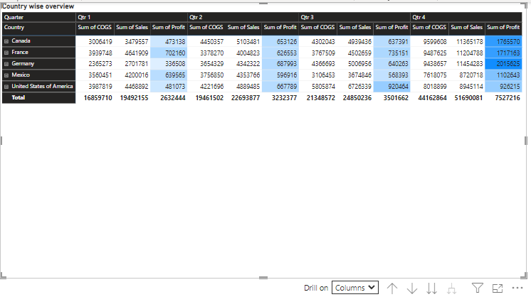

Drill through month wise:

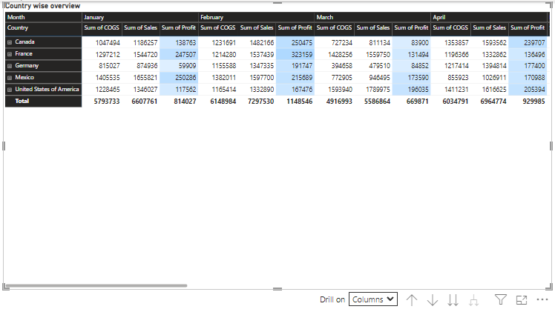

1. Add the reset image in which all the filters should get removed and the report page should be default in the country information page.

Ans)

Added a bookmark when the page was not in drill down mode and updated the “reset page”

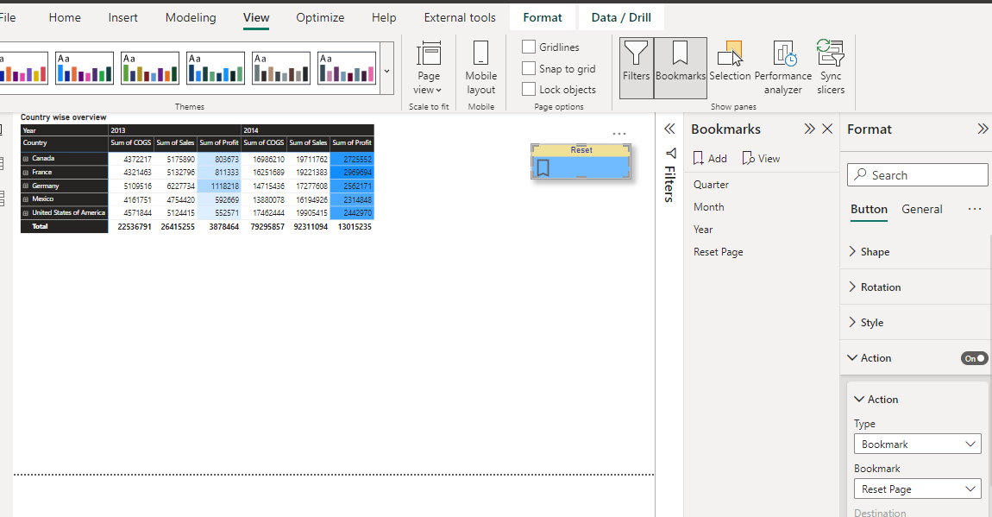

Active drill down mode:

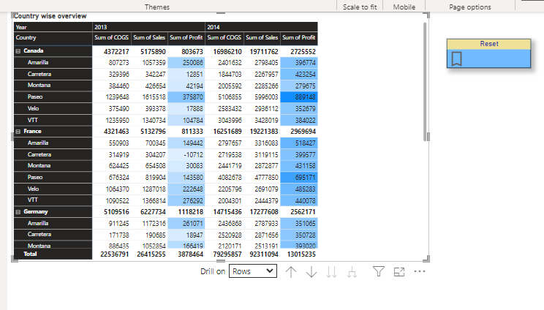

Clicked on Reset bookmark:

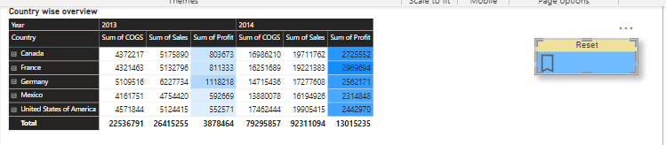

### Day-11

1. Create a new summarize table with selected columns (region, country, sum of sales) from the global superstore and filter the region based on the given conditions, Central Asia, North, South & East.

Ans) Added filters with options: (Central Asia, North, South, and East)

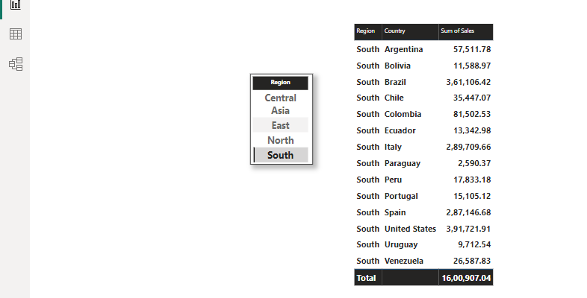

### Day-12

1. Create a week column based on the order date from the global superstore data.  
   e.g. required output “Week-5”

Ans) Added a column “Week Number” based on “Order Date” (using column from example)

Used Week-5 as filter to show required output:

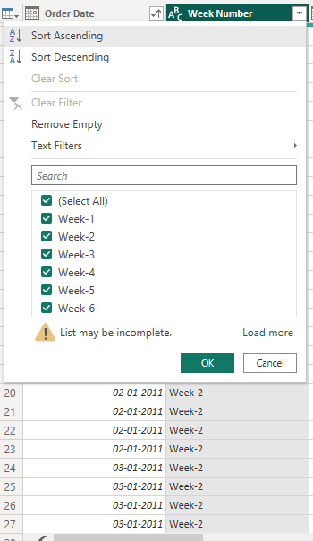 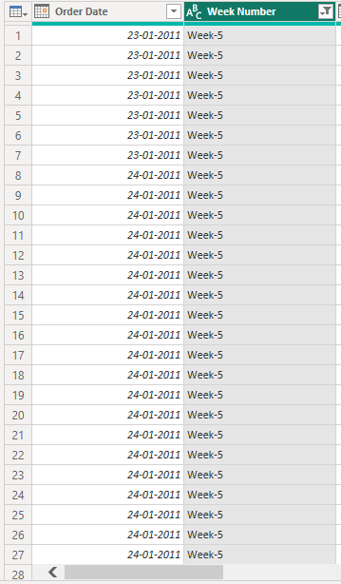

### Day-13

1. Create a table visual to show the current month's sales vs last month's sales.

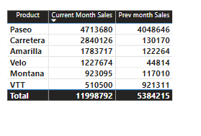

Dax Formulas:

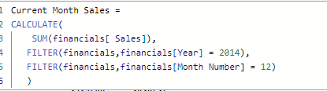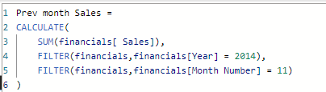

### Day-14

1. Insert the scroller custom visual and add it to the report page referring to the country and profit column.

**Ans:** Downloaded the scroller visual and added country by profits to show this visual



### Day-15

1. Create a shared workspace and add the organization members to the workspace then publish the report.

Ans)

Added workspace name “Hari”

Added two members to the workspace name “Hari”

